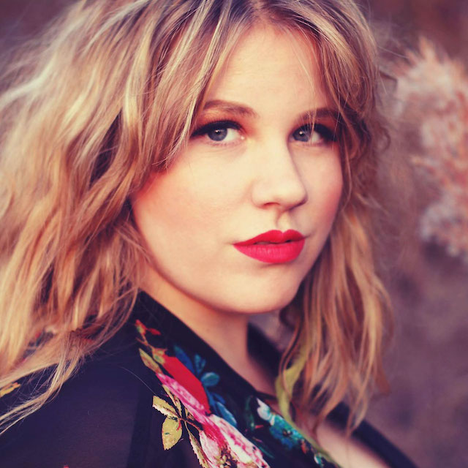
Kristen Englenz

Nashville-based singer-songwriter Kristen Englenz paints musical stories of loss and heartache with a soulful sensibility both intimately aching and defiant with hope. A multi-instrumentalist classically trained in piano with a voice virtuosic and vulnerable, her music is fragrant with Americana roots infused with an indie vibe.

Roots music journal No Depression called Englenz’s music “stream of consciousness Beat poetry imbued with good-down-home Southern sensibility.” And Stomp and Stammer said, "There is a stirring intimacy to these performances that holds you in their grasp."

Englenz attributes her melodies to be partially inspired by the natural world. Her interest in environmental activism is shared in her popular web series “Caterwauling with Kristen” where she mimics birdcalls and teaches about avian species.

“I don't know why a certain chord progression makes us want to cry or to laugh,” says Englenz. “If we figured that out, we would probably understand birds and nature much better!”

Englenz’s debut full length album, ingénue, was recorded in Nashville by three-time Grammy nominee and producer Ken Coomer, former drummer for Wilco. It includes a collaboration with five-time Grammy winning gospel legends the Blind Boys of Alabama and was recorded at FAME Studios in Muscle Shoals. It released February 28, 2020.

The East Nashvillian called the debut album “a sonic wonderland” and Creative Loafing says, “Kristen Englenz shines…with a strong opening salvo.” Stomp and Stammer stated comments that "ingénue features strong lyrics delivered by
an emotive storyteller...a talent with the drive to work as an equal
with roots music legends.

The focus track, “Pray for Rain” has been played on over 500 playlists, along with Amazon’s “Fresh Folk” and Modern Folk”, Apple’s “Eclectic Wax” playlist and was a pick for The Alternate Root’s “Top Ten Songs of the Week”. It was a selected song on Paste Magazine’s November 2019 podcast, “Best Albums of 2019.” Americana Highways says, “Englenz very effectively harnesses a sense of healing and hope and the Blind Boys of Alabama magnify the potency.” SoundBites called it “among the best tracks to emerge in 2020 so far.”

The album explores themes of vulnerability, betrayal and hope. Englenz cries out to the lonely and the lost, opening portals for the passage of grief as well as reassurances that we are not alone.

“Sometimes it can feel like you're damaged, defective, not worth being seen,” she says. “We all have these stories.”

A fast-rising fixture of the East Nashville music scene where she now lives, Kristen was born in Texas and raised in Georgia. Englenz frequently performs at Nashville venues The 5 Spot, The Basement, and The Bowery Vault, as well as at famed Eddie’s Attic in her hometown of Decatur, Georgia. She has played live on Opryland radio, WSM AM, and has been a featured guest on several Americana radio stations including WMOT, WMFU and NolaCounty.

Englenz has opened for and shared the stage with the Blind Boys of Alabama along with other Americana artists.

Englenz was recently signed by Atlanta, Georgia-based indie label, Saturn 5 Records.

